How to install new plug-ins in SpinStudioJ

Methods for installing new plug-ins
There are two methods to install new plug-ins for SpinStudioJ: first is installation from wizard, second is installation by copying plug-ins to the “plugins” folder of SpinStudioJ.
1.1 Installation from wizard
Step 1. Open SpinstudioJ software; On the main menu bar, click Help> Install new software.
Maybe an error will appear as follow. Ignore it and click button “OK”.
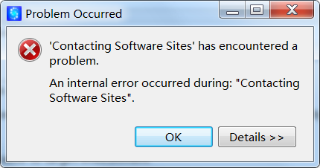
Then the Installation wizard will display.
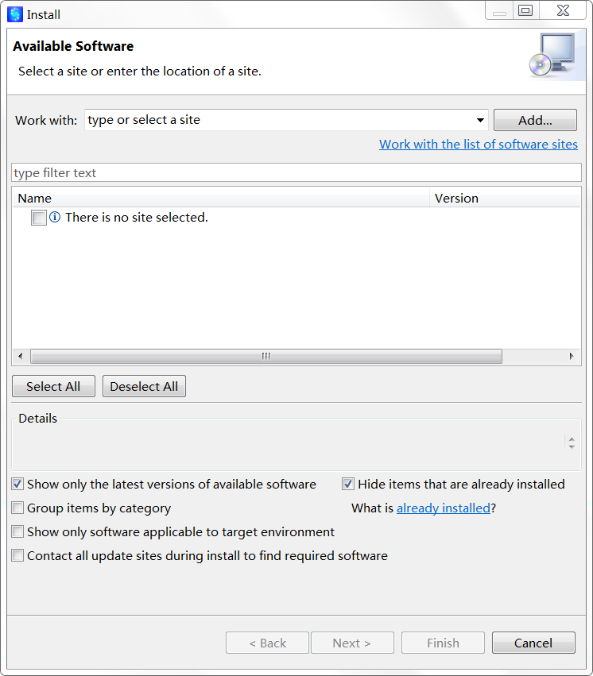
Step 2. Click button “ Add “. Dialog for adding repository will display as follow.
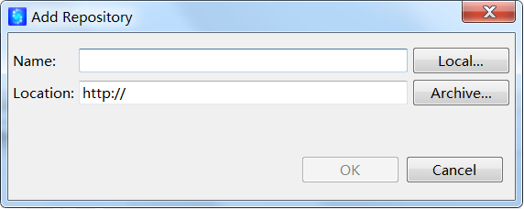
Step 3. Click button “Local”; Select the folder which includes “features” and “plugins” .For example , select “PluginsRepository”.
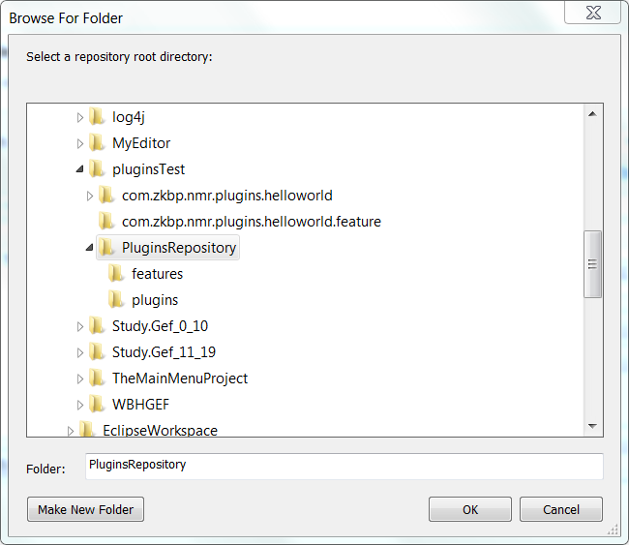
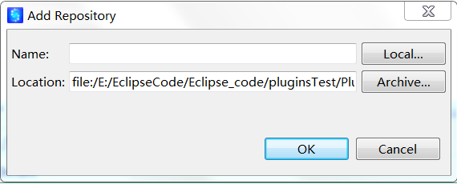
Click button “OK”.
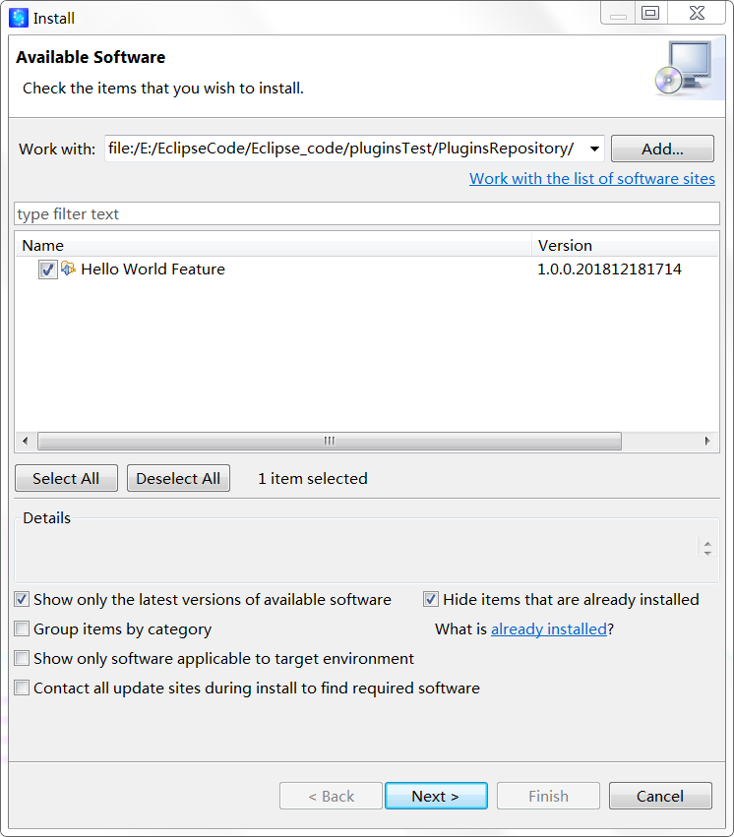
Step 4. Select the features which you want to install. Click button “Next”.
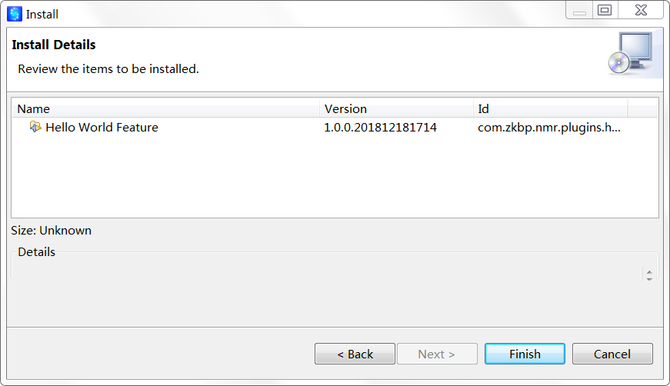
Click button “Finish”. Maybe a warning will appear. Ignore it and click button “OK”.
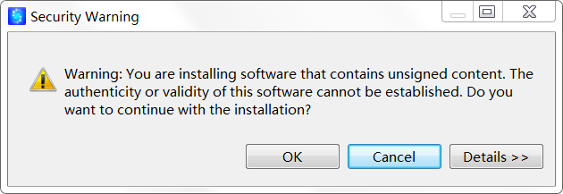
Step 5. After installation ,you will need to restart SpinStudioJ. In “Software Updates” dialog, click button “Yes” to restart SpinStudioJ.
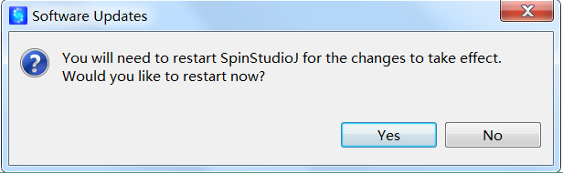

1.2 Manual Installation
Copy the plug-in files into the plug-in folder (named “plugins”) of SpinStudioJ.
Then restart SpinStudioJ. The plug-ins will be installed.
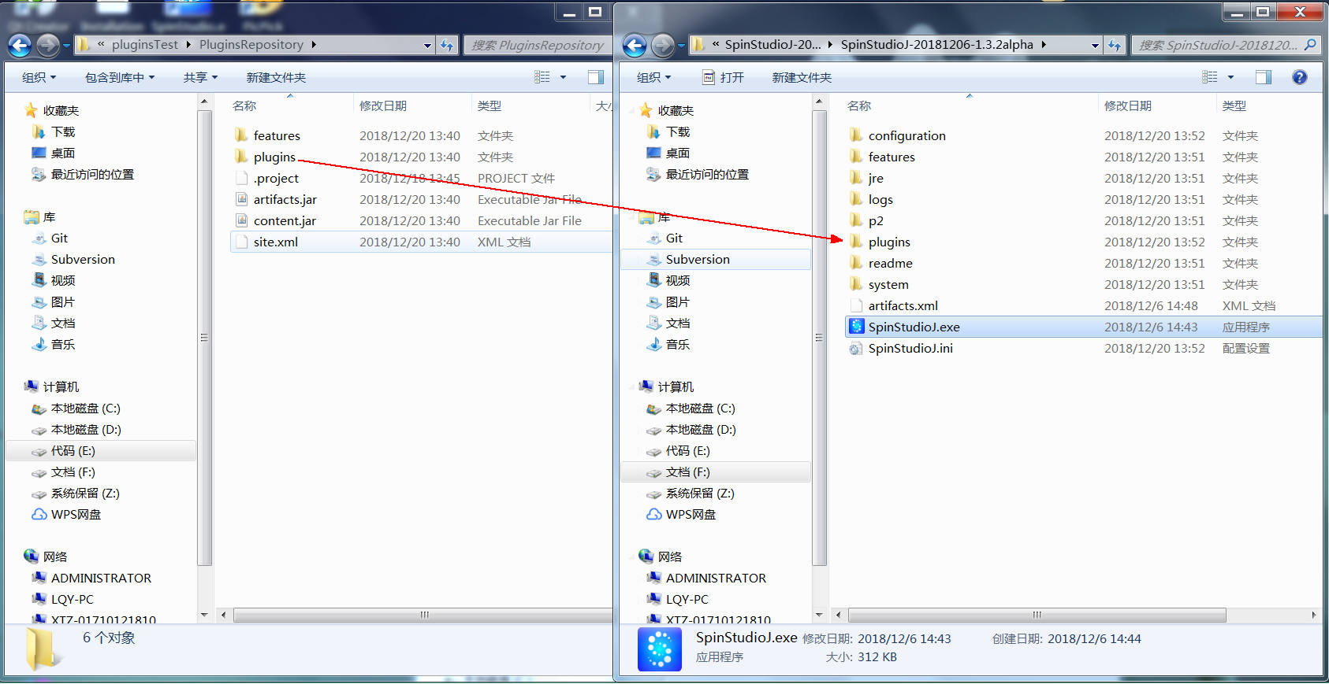

Installation result .
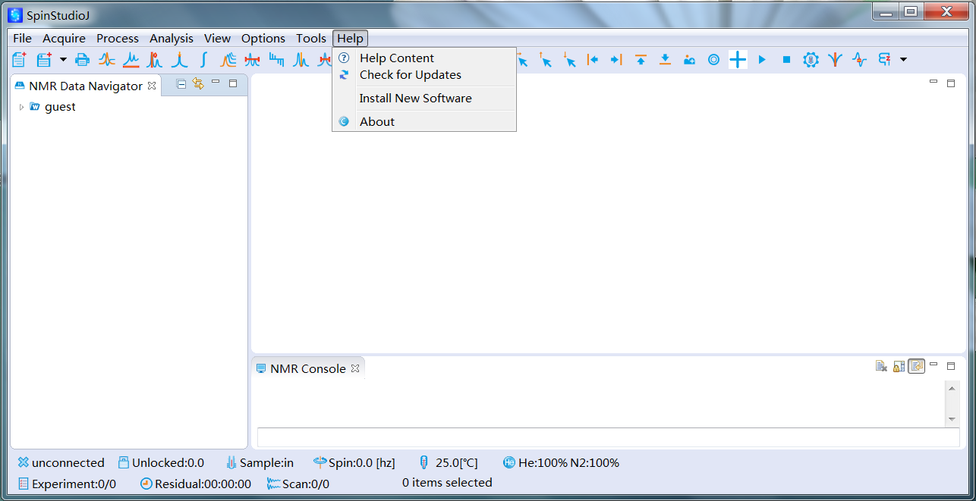
SpinStudioJ before installation of Hello World plug-in.

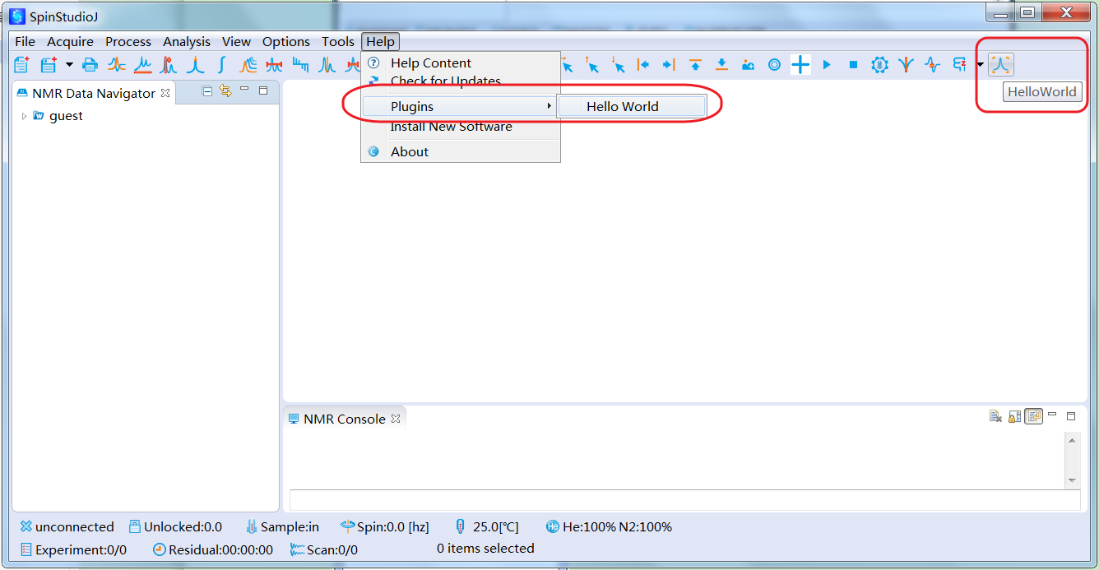
SpinStudioJ after installation of Hello World plug-in
On the main menu bar, click Help>Plugins>Hello World. You can also click the button “HelloWorld” on tool bar. Hello World dialog will display.

